|  |  |
| --- | --- |
| Assignment Date | 09 september 2022 |
| Student Name | V kalpana |
| Student Roll Number | 962719106012 |
| Maximum Mark | 2 marks |

1. Split this string

s = "H ithere Sam"

solution:

string="Hi there sam!"

print(string.split())

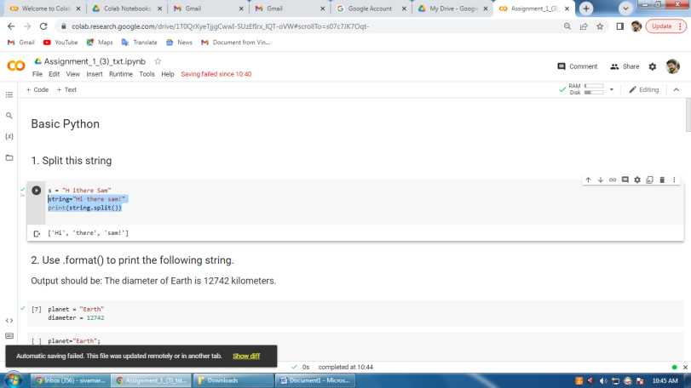

## 2. Use .format() to print the following string.

### Output should be: The diameter of Earth is 12742 kilometers.

planet = "Earth"

diameter = 12742

solution:

planet="Earth";

diameter=12742;

print("The diameter of"+planet+"is",diameter,"kilometers")

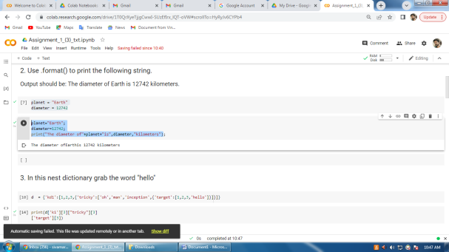

## 3. In this nest dictionary grab the word "hello"

d  = {'kd1':[1,2,3,{'tricky':['oh','man','inception',{'target':[1,2,3,'hello']}]}]}

solution:

print(d['k1'][3]["tricky"][3]

['target'][3])

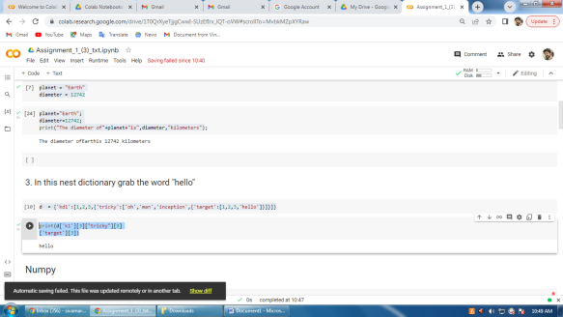

## 4.1 Create an array of 10 zeros?

Solution:

import numpy as np

array=np.zeros(10)

print("An array of 10 zeros:")

print(array)

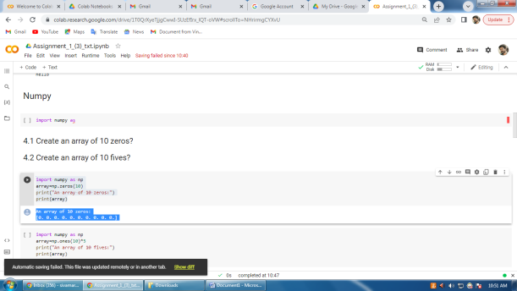

4.2 Create an array of 10 fives?

Solution:

import numpy as np

array=np.ones(10)*5

print("An array of 10 fives:")

print(array)

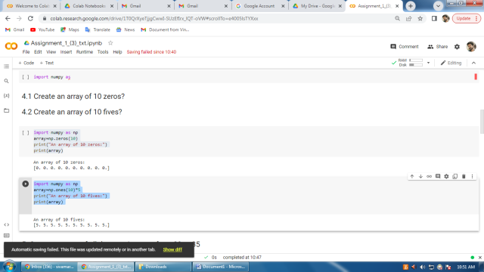

## 5. Create an array of all the even integers from 20 to 35

Solution:

import numpy as np

array=np.arange(20,35,2)

print("Array of all the even integers from 20to 35")

print(array)

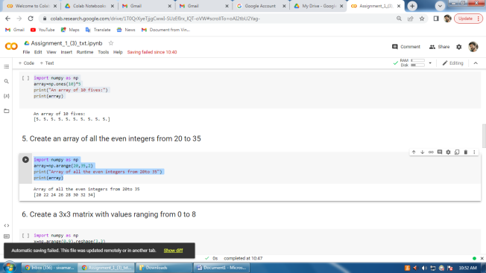

## 6. Create a 3x3 matrix with values ranging from 0 to 8

Solution:

import numpy as np

x=np.arange(0,9).reshape(3,3)

print(x)

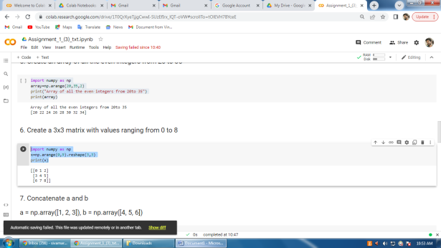

## 7. Concatenate a and b

## a = np.array([1, 2, 3]), b = np.array([4, 5, 6])

Solution:

import numpy as np

a=np.array([1,2,3])

b=np.array([4,5,6])

arr=np.stack((a,b),axis=0)

print(arr)

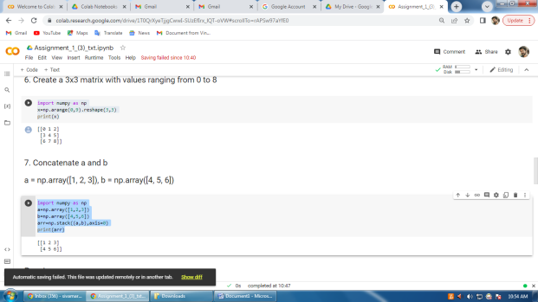

8. Create a dataframe with 3 rows and 2 columns

Solution:

import pandas as pd

data=[['tom',10],['nick',15],['juli',14]]

df=pd.DataFrame(data,columns=['Name','Age'])

df

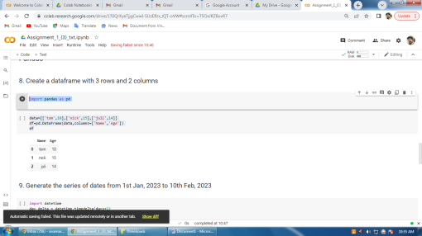

## 9. Generate the series of dates from 1st Jan, 2023 to 10th Feb, 2023

Solution:

import datetime

day_delta = datetime.timedelta(days=1)

start_date = datetime.date(2023,1,1)

end_date = start_date+41*day_delta

for i in range((end_date-start_date).days):

     print(start_date + i*day_delta)

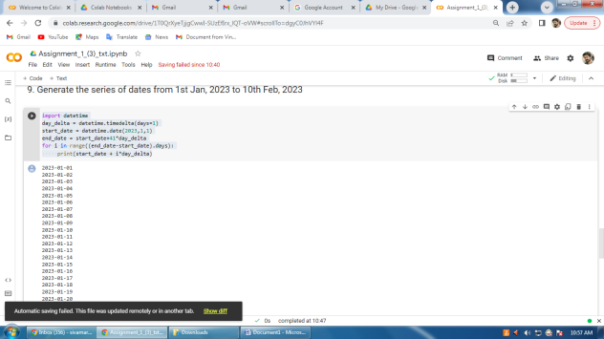

## 10. Create 2D list to DataFrame

Solution:

df=pd.DataFrame(lists,columns=['Number',"Letter",'Number'])

print(df)

